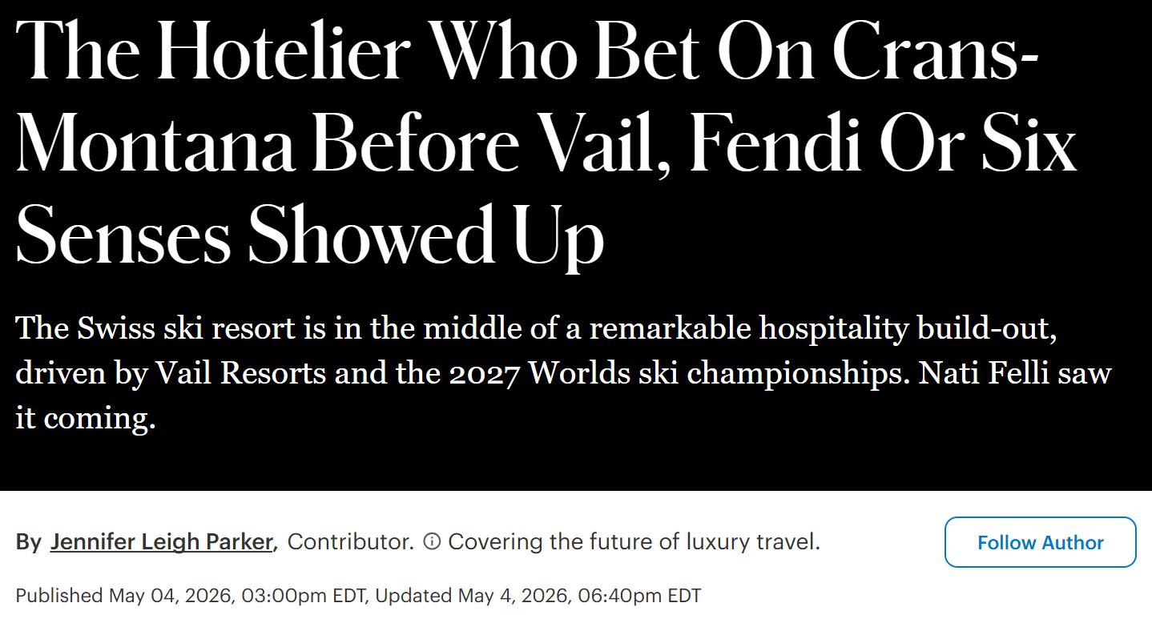
The Hotelier Who Bet On Crans-Montana Before Vail, Fendi Or Six Senses Showed Up
The Swiss ski resort is in the middle of a remarkable hospitality build-out, driven by Vail Resorts and the 2027 Worlds ski championships. Nati Felli saw it coming.
By Jennifer Leigh Parker, Contributor
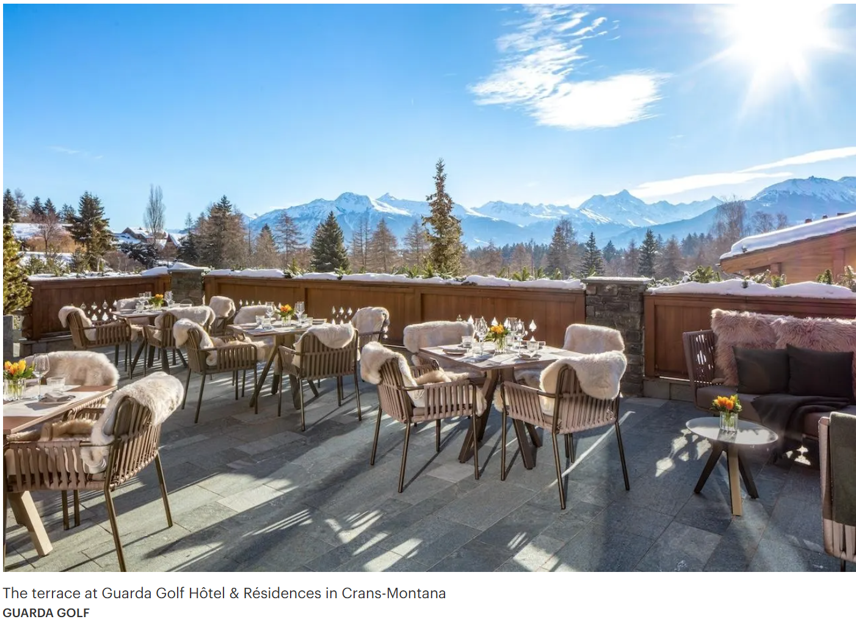
Crans-Montana is repositioning itself from a somewhat tired legacy resort — historically popular but under-invested compared to Verbier and Zermatt — into a destination with international brand density built on three key advantages. They’ve got the Omega European Masters golf tournament, the coming FIS Alpine World Ski Championships, and Vail Resorts’ 2024 acquisition of the Crans-Montana mountain resort, including an approximate $38 million capital injection meant to “elevate the guest experience.” The investment by Vail Resorts was essentially an imprimatur from one of the world’s largest ski corporations, and gives Crans-Montana a chance to move from being a domestic destination to an international one.
Several major openings are in the 2026 pipeline: the boutique hotel Luciole, replacing the current Mirabeau; the Fendi Private Residences on the site of the century-old Alpina & Savoy Hotel; and Le Guépard Palace & Residences, developed by Christian Constantin SA. And all of this comes on the heels of the glitzy opening of the Six Senses Crans-Montana ski-in, ski-out resort, and the nouveau riche crowd that comes with it.
The timing isn’t coincidental. Crans-Montana's successful bid to host the FIS ski championships in February, colloquially known as ‘2027 Worlds’, was awarded partly because of this accelerated hotel and infrastructure pipeline.
Only a few people saw this growth potential decades ago. Nati Felli, the Brazilian hotelier and owner of Guarda Golf Hotel & Residences, where the Omega European Masters is played every year in September, is one of them. Plenty of buyers want her five-star property — but she’s fiercely independent. And she’s not going to sell.
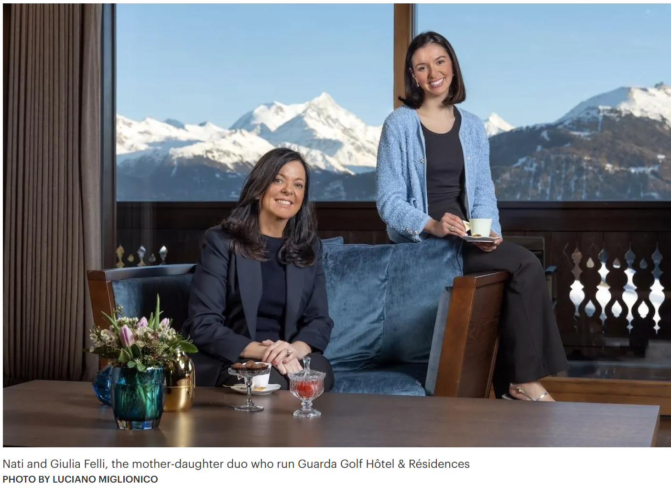
Born and raised in Bauru, São Paulo, Nati Felli grew up in a family who developed agriculture and real estate. Understanding property value is in their blood. So is ambition. Looking to broaden her horizons after University, she enrolled at Les Roches, a prestigious Swiss hospitality school, determined to learn hotel management from the best in the business. By 1998, she’d begun planning, building and investing in Crans-Montana. And in December 2009, Nati and her husband Giancarlo Felli officially opened Guarda Golf Hotel & Residences.
Today, Madame Felli still runs the hotel, alongside her business partner and hotel manager of 12 years, Simon Schenk, and her daughter, Giulia Felli, the hotel’s marketing and sales executive. Together, they manage a team of 75 seasonal staff members looking after 23 rooms and six suite apartments, just small enough for high-profile guests who prefer privacy over a large hotel. Sir Roger Moore was such a regular the hotel's private cinema is named after him. Rory McIlroy, winner of the 2025 Masters Tournament, was a guest. And more recently, George Clooney, a long-term brand ambassador for Omega, came to visit.
The power of high-profile sports events and membership with Leading Hotels of the World and Virtuoso, a global network of luxury travel agencies, greatly helps the Fellis maintain ownership — at a time when the pressure to sell out to a larger corporate brand is high.
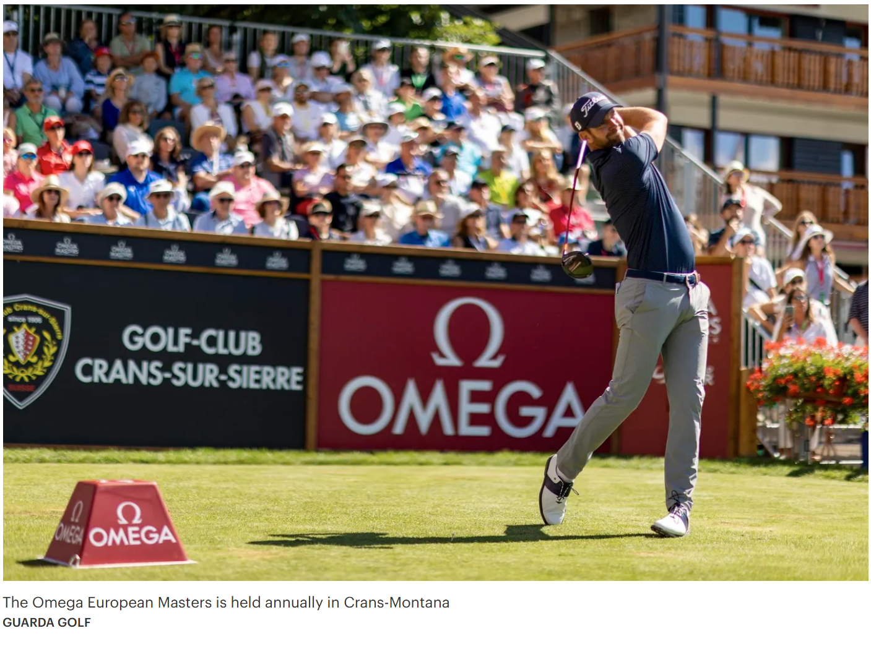
Still, I wonder how this young Brazilian girl got her start in Switzerland’s old boy’s club golf-and-ski scene in the first place. So I listen to her story, as she sits by her fireplace in a sumptuous apartment-suite, sipping tea from hand-painted butterfly china (her favorite symbol of transformation), the snowy peaks of the Valais basking in the sun behind her.
“I convinced the Swiss government that I was the person to represent Brazil here. That's how I started to bring Brazilian clients to Les Roches and to all hotels in the region. That was my idea. I discovered in the law that if I can prove financial independence, and bring something for the government, I would have a B visa. I didn’t want to marry anyone for a visa. I wanted my own independence,” she says, with a passion in her voice the Swiss might call dramatic.
Paradoxically, obtaining independence from Brazil, which is challenged by systemic corruption, fully depends on fostering her relationship and ties to her home country. Swiss luxury tourism industry insiders — particularly at St. Moritz, Verbier, and Gstaad — have long recognized Brazilians as a high-spending and growing cohort, even if the official statistics lump them into “other Americas.” Felli not only understood the value of Brazilians to Crans-Montana way back when, but now has a distinctive advantage in catering to them. After all, she speaks their language and understands their expectations when it comes to hospitality.
“You have big fortunes in Brazil. The most important family in Brazil trusts us and invests in the hotel,” Felli explains. “All my clients have that feeling of trust because for many years they can see we can build things without being corrupted. I'm very neutral. So they want to work with me.”
If You Build It, The Brazilians Will Come
Of course, there is the status factor. Brazil has no domestic skiing tradition at scale. For wealthy Brazilians, a glitzy week in the Alps is not just a vacation — it's a culturally loaded status signal in a way that a beach holiday is not. There is also asset protection to consider. For Brazilians used to political and currency volatility at home, Swiss Alpine real estate is a safe haven. But they need to find inventory, which can be tricky. Firstly, it’s increasingly expensive, according to UBS’ 2025 Alpine Property Report. And the Swiss alpine property market has long struggled with a shortage of supply, especially in its most popular resorts. Here, Knight Frank names Crans-Montana as an emerging alternative:
“We are also seeing interest rising in other resorts that are investing heavily in their future. Take Crans-Montana, as one example, where Vail Resorts’ acquisition of the ski domain is attracting more American buyers due to their established brand presence. Andermatt is seeing similar momentum, with substantial funds being poured into its development,” says Koch de Gooreynd at Knight Frank in Barclays’ Swiss Property Market Report.
Crans-Montana has an active development pipeline, holding a large share of new-build permits for properties that can be sold to foreigners in the canton of Valais. For example, the Fendi Private Residences with its 124 new apartments and Le Guépard Palace residences are currently in play. For its part, Guarda Golf already offers private residences in three different buildings. But its owners intend to expand. It’s an optimistic move for a town that’s been through hell.
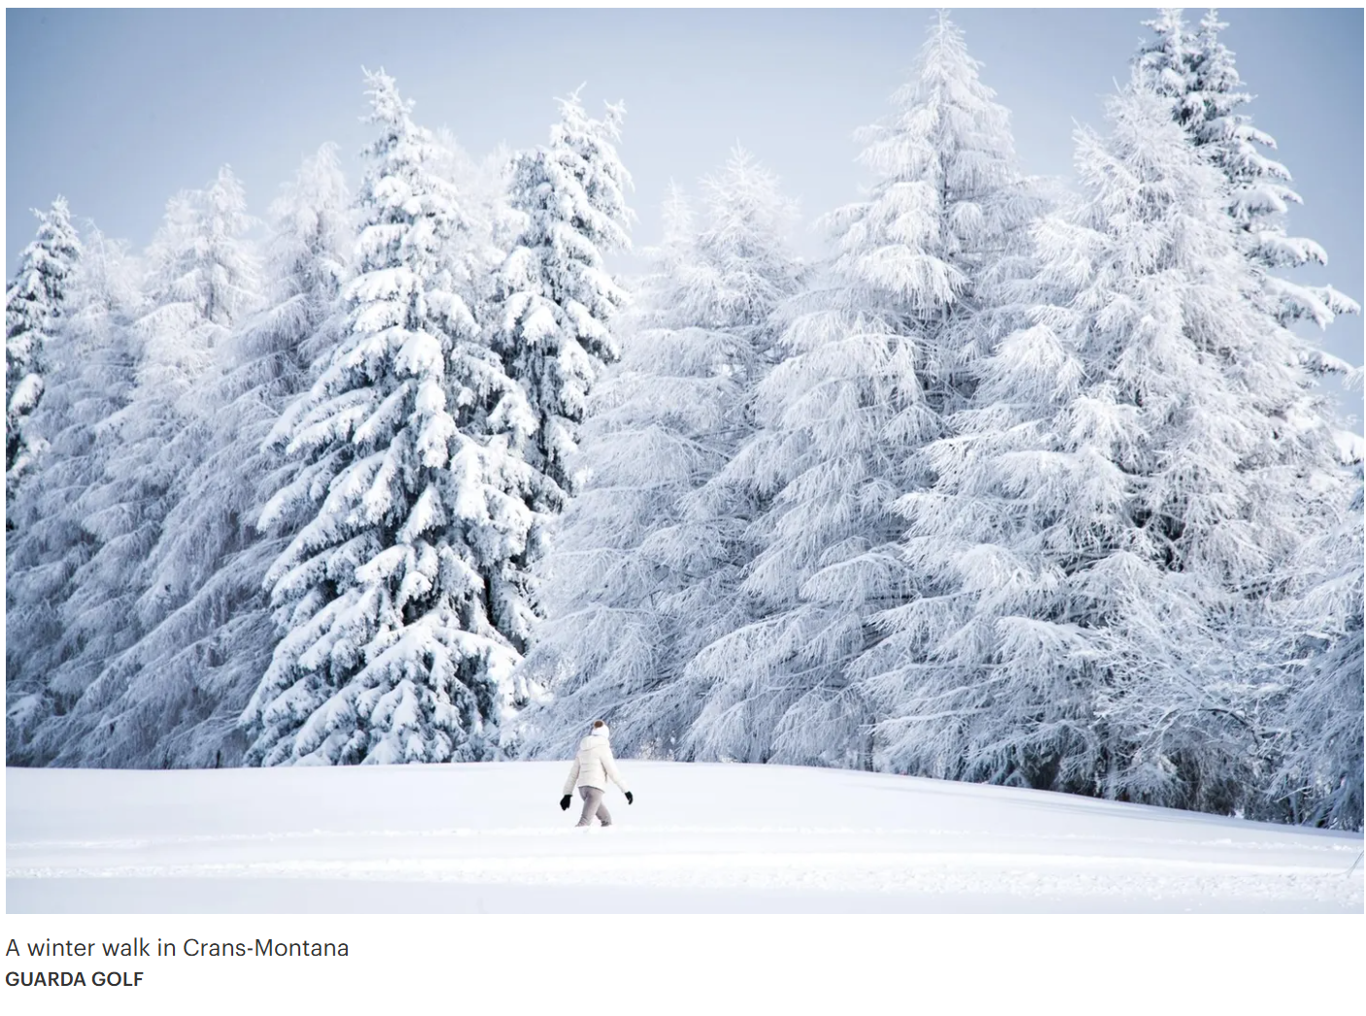
After the Fire: The Road to Recovery
On New Years Eve night, 2025, sparklers on champagne bottles ignited acoustic foam on the ceiling of Le Constellation bar in Crans-Montana, killing 41 people and injuring more than 100. Most victims were teenagers and young adults visiting the ski resort with their families, who often come here from Lausanne and Geneva to ski. That bar, since shut down, is an eight minute walk from the Guarda Golf hotel. This is a small village in a tight-knit community. They were shocked and devastated. And it impacted everyone.
The Swiss changed their laws rapidly in response. The intercantonal body known as the Intercantonal Authority for Fire Safety adopted a nationwide ban on indoor pyrotechnic devices (the sparklers) in March 2026, with its president, Jean-François Steiert, explicitly stating that the measure was “a direct consequence” of the Crans-Montana fire.
“We're lucky to live, and I think it's also our duty to move on. But of course, it's very sensitive. What can you do? When do you move on?,” reflected Simon Schenk, hotel manager and residential owner’s representative at Guarda Golf.
Come September, the first Omega Masters golf tournament will be a full circle moment for a town still in recovery. And of course Vail Resort’s first ski season since the fire, with its accessible Epic Passes, is something avid skiers are looking forward to. And I can see why.
On a dazzlingly bright, blue-bell morning, the Valais Alps really puts on a show. Nati’s daughter Giulia Felli points out the summits of the Matterhorn to my left. And Mont-Blanc straight ahead. It’s the kind of unbelievable view that stops you in your powdery tracks, if only to appreciate your relative insignificance. I inch my way down a steep hill toward the modern alpine lunch spot, Chet Zeron, grateful that Felli, Crans-Montana born and bred, worked as a teen ski instructor here for three years — and offers me an arm to lean on. Now in her 20s, with a degree in economics and law from the University of Fribourg, she could choose many different paths. But she’s choosing to look after Guarda Golf, the family business.
“There’s an important cultural norm in Swiss cantons, which operate a bit like states and have some freedom to make their own rules. It’s la parole (your word). Your word is your bond,” she said, before speeding down the piste, with the ease of an athlete.
Over the years, the Felli’s word with their clients has won them independence. Now, the story of Guarda Golf — apart from being where Lindsey Vonn skied or where Jack Niklaus has a golf course — is a story of a mother and daughter who took a chance on each other. With one facing retirement and the other facing uncertainty, they made a promise. They will not sell out. Because they don’t have to.

Find official article here: The Hotelier Who Bet On Crans-Montana Before Vail, Fendi Or Six Senses Showed Up

