
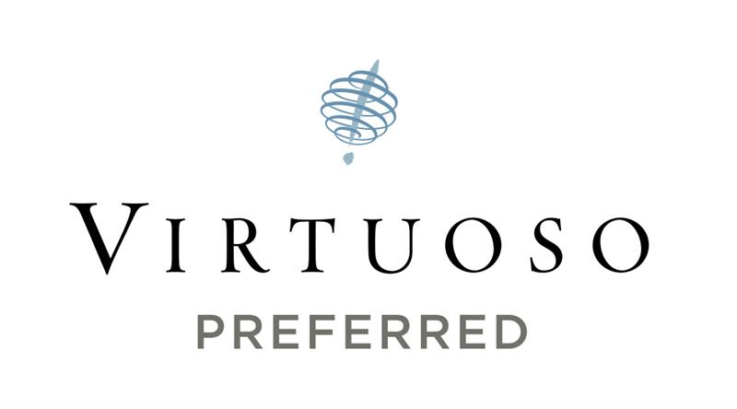

GUARDA GOLF HOTEL & RESIDENCES ACCEPTED INTO GLOBAL LUXURY TRAVEL GROUP VIRTUOSO

CRANS-MONTANA, SWITZERLAND (April 29, 2026) – Guarda Golf Hotel & Residences has been accepted into Virtuoso’s exclusive portfolio of luxury travel partners, comprising 2,500 preferred suppliers in 100 countries. According to Nati Felli, owner and founder of Guarda Golf Hotel & Residences, inclusion in Virtuoso will present new sales and marketing opportunities to the network’s luxury travel advisors and their highly desirable clientele. Virtuoso agencies worldwide sell an average of (U.S.) $35 billion annually, making the network the most significant player in luxury travel.

“Virtuoso’s acceptance process is incredibly selective, so becoming a preferred partner is a true honor,” said Felli.
“The reputation Virtuoso member agencies have for outstanding dedication to their clients is a perfect fit with our own bespoke approach to service. Now that we’re part of this renowned network, we look forward to offering Virtuoso advisors and their clients the special amenities, values and experiences that surpass their expectations.”

Guarda Golf Hotel & Residences joins Virtuoso’s collection of the finest luxury hotels, resorts, cruise lines, airlines, tour operators and other travel entities worldwide. These partners, which specialize in world-class client service and experiences, provide superior offerings, rare opportunities and exceptional value for Virtuoso clients. These prestigious providers are able to market to Virtuoso clients via network vehicles and to Virtuoso agencies through multiple communications channels and events, including Virtuoso Travel Week, luxury travel’s preeminent worldwide gathering. Guarda Golf Hotel & Residence’s acceptance into Virtuoso gives it direct relationships with the world’s leading leisure travel agencies in North and Latin America, the Caribbean, Europe, Asia-Pacific, Africa and the Middle East.

Guarda Golf Hotel & Residences is an alpine property whose intimate scale allows Virtuoso advisors’ clients to be recognized and cared for as personal guests of the house, rather than room numbers. As a Virtuoso partner, we layer the program’s value-adds (breakfast, upgrade subject to availability, early check-in/late check-out where possible and $100 USD F&B credit-value) onto a highly personalized, residential-style welcome, so that Virtuoso travelers experience the stay as a private mountain home with genuinely tailored service.

For more information about Guarda Golf, call +41.27.486.2000 or visit guardagolf.com

About Guarda Golf Hotel & Residences
With an exceptional location in the center of Crans-Montana, in the heart of the Swiss Alps, Guarda Golf Hotel & Residences is a breathtaking place to stay in both the summer and the winter months. Crans-Montana benefits from world-class golf courses, 140 km of ski slopes and a vast choice of luxury boutiques and restaurants. In the summer, the location adjacent to the golf courses is ideal, and in the winter, the ski slopes are but a few minutes’ ride with the hotel’s limousine transfer service.

A Virtuoso partner; member of Leading Hotels of the World & Swiss Deluxe Hotels, the hotel’s modern alpine chalet-style décor and its flawless, friendly and personalized service ensure a cozy, intimate and discreet welcome. The 23 rooms and suites are all fitted with natural materials and appointed with taste. All guests benefit from daily breakfast, private transfers throughout Crans-Montana, complimentary access to the Guarda Golf Spa and Wi-Fi throughout the hotel.

The 6 luxury suite-apartments are each laid out over 225 m2 and provide an incredible level of comfort and luxury. Each one includes three bedrooms, a generous living room with a dining area and fireplace with a fully equipped kitchen and a large terrace.

Restaurant FIVE, the hotel’s main restaurant, offers authentic cuisine of the Levantine region. The name and the concept are inspired by five essential foundations: a generous welcome, a convivial sharing, a respect of nature’s produce and a contemporary interpretation of flavors as well as the culinary heritage of the cuisine of the Levant. The Guarda Golf Lounge serves international classics all day long. In the evening, the fireplace sets the stage for casual dining. Stunning cocktails, wines and refreshing drinks are offered at Les Alpes Bar and are the perfect way to start or conclude your dinner.

The elegant Guarda Golf Spa offers a variety of intimate spaces over its 600 m2, home to a heated pool, whirlpool, sauna, hammam and four treatment rooms, including a Spa Suite designed for couples with its own private whirlpool and hammam. Completing the picture is an indoor golf practice area and a well-equipped fitness room. Sophisticated facial treatments by the cutting-edge Swiss brand La Colline are exclusively offered at the Guarda Golf Spa. High-end natural products by KOS Paris complement a selection of massages and beauty rituals.

The range of leisure facilities at the hotel is completed by the 15-seat Sir Roger Moore Private cinema, a library, billiard room, secured Golf & Ski room, kid’s playroom and cigar lounge.

About Virtuoso
Virtuoso is the leading global travel agency network specializing in luxury and experiential travel. This by-invitation-only organization comprises over 1,200 travel agency locations with more than 20,000 travel advisors in 58 countries throughout North America, Latin America, the Caribbean, Europe, Asia-Pacific, Africa and the Middle East. Drawing upon its preferred relationships with 2,500 of the world’s best hotels and resorts, cruise lines, airlines, tour companies and premier destinations, the network provides its upscale clientele with exclusive amenities, rare experiences and privileged access. Annual sales of (U.S.) $35 billion make Virtuoso a powerhouse in the luxury travel industry. For more information, visit www.virtuoso.com.

# # #

Media Contacts: Giulia Felli
Sales, Marketing & PR
Guarda Golf Hotel & Residences
+41.79.255.2211
pr@guardagolf.com

Misty Belles
Vice President, Global Public Relations
Virtuoso
Phone: +1.202.553.8817
Email: mbelles@virtuoso.com

