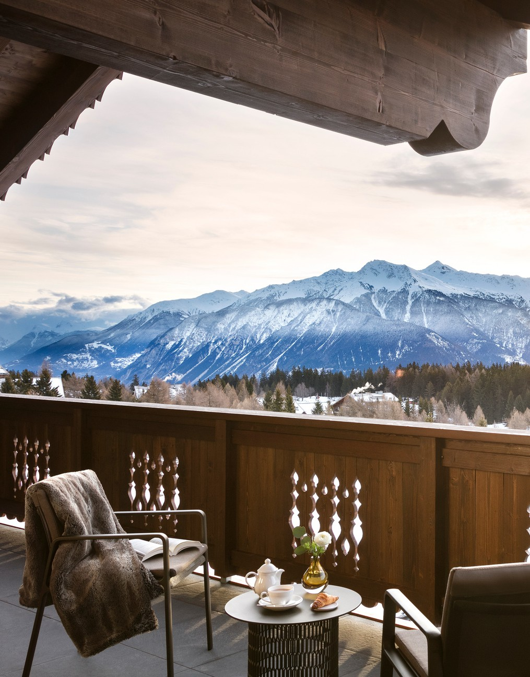

PRESS RELEASE
New exclusive
collaboration
Guarda Golf Hotel & Residences partners with Elodie Richard, a nutritionist, specialised in micronutrition, for a tailor-made programme to get back into shape.

Crans-Montana, Dececmber 2023 - With its exclusive programme combining healthy nutrition, physical activity coaching and spa treatments, Guarda Golf Hotel & Residences is once again demonstrating its commitment to making every stay beneficial to its guests. Hand in hand with the nutritionist Elodie Richard, the new offer encourages everyone to discover the transformative effects of balanced nutrition, all within an ambience designed for ultimate relaxation and renewal. Our body is a precious ally deserving our utmost care and attention.
The new "Health & Balance" programme is entirely personalised and organised over a minimum of three days.

A preventive objective : (re )learning and understanding what is good for the body
United by shared values, the management of Guarda Golf Hotel & Residences and Elodie Richard come together to provide bespoke guidance to clients, prioritising their well-being.
«Health & Balance» is aimed at getting back into shape through balanced nutrition, sporting guidance and spa treatments. Emerging from a distinguished career in luxury hospitality, Elodie Richard brings a profound understanding of unparalleled service and care.
In 2017, what could have been a crushing blow transformed into the start of a new chapter in life, driven by passion. Seven years ago, Elodie encountered a significant health scare.
Throughout a challenging journey from which she emerged stronger, she understood the importance of nurturing the body. The body is often neglected when everything is going well. Alongside her primary career in the luxury sector, Elodie pursued her growing passion for nutrition and successfully obtained a Certificate in Nutrition and Vital Hygiene from the Holistic Nutrition School of Geneva. She recognised the importance of understanding, becoming aware, and taking steps forward. However, her vision is about acting together, with a primary wish to pass this knowledge to those close to her heart and then extend her reach further.
«Today, I am deeply committed to hearing the personal narratives of my clients, guiding them towards better care of their bodies. Together, we shall explore what truly resonates with them, seamlessly integrating this journey with the joy of living.» More than just learning, the aim is to raise awareness by reminding people of the fundamentals so everyone can continue this journey independently afterward.
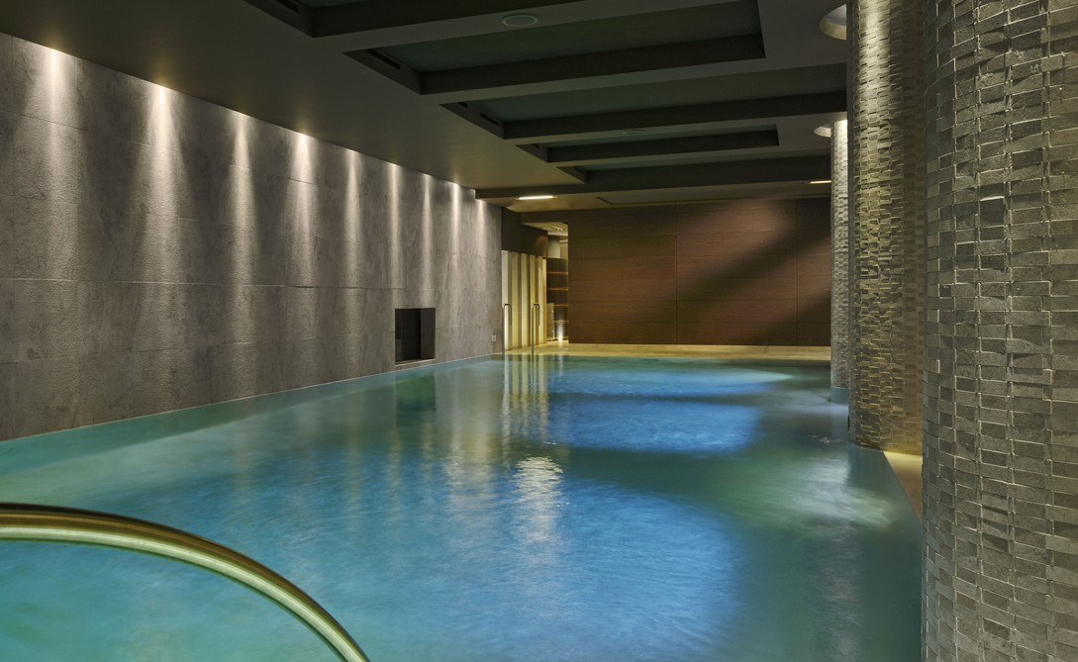
Nutrition plays an essential role in the prevention of diseases. This bespoke program caters to individuals aspiring to: rebalance their nutritional intake - regain vitality - reduce stress – release some excess weight - reduce the risk of inflammatory crises - detoxify the body - reduce water retention – improve sleep quality.

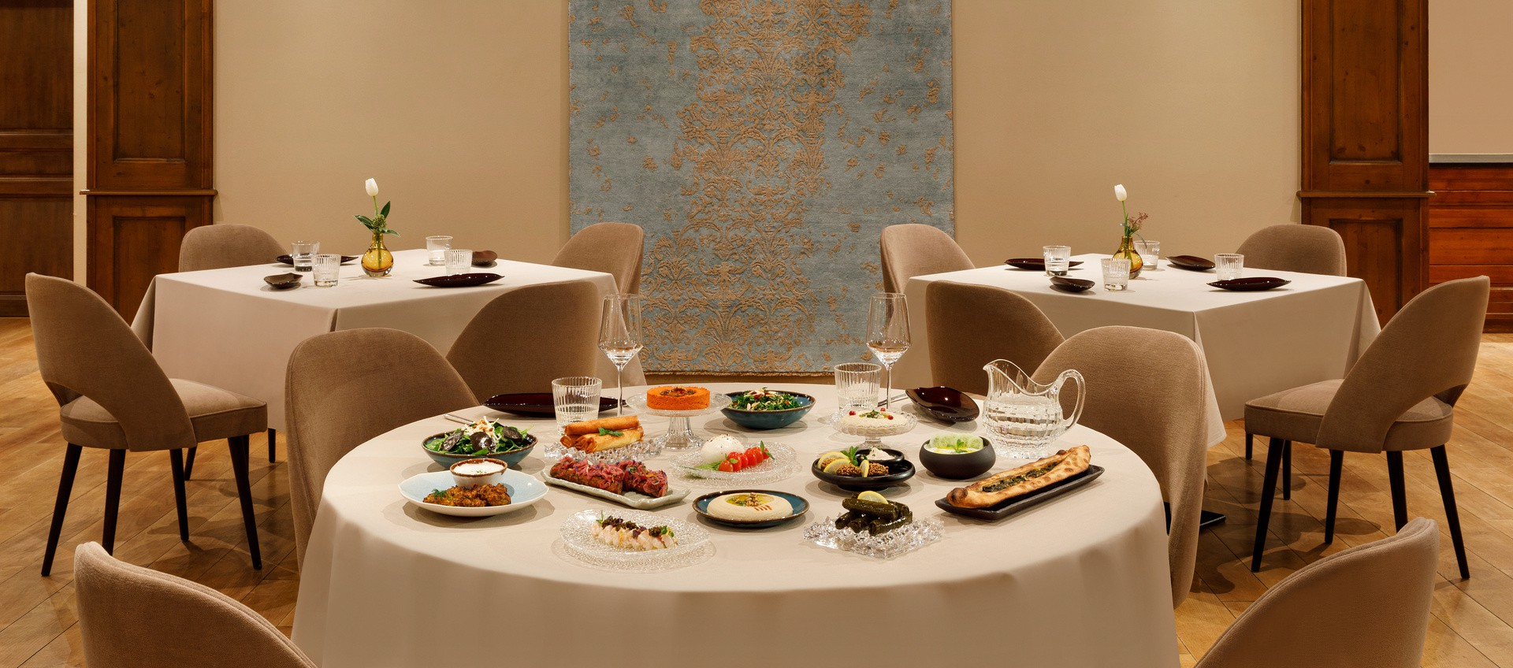
Guarda Golf Hotel & Residences, its restaurant and spa as the ultimate setting
The Mediterranean cuisine of Restaurant FIVE is ideal in this journey towards healthy eating as it provides all the essential nutrients the body needs. It maintains a balance between lipids, carbohydrates, and proteins. What's more, its composition, rich in antioxidants, Omega-3 and vitamins, has significant anti-inflammatory properties. Fully integrated into the personalised programmes, the restaurant’s culinary offerings demonstrate that balanced healthy meals do not have to compromise on the joy of good food.
Meanwhile, the treatments at Guarda Golf Spa serve as an essential complement, providing effective results. The extensive selection of treatments offered by the wellness skilled practitioners is the perfect ally for achieving overall well-being, from body wraps to massages and the Renata França method of lymphatic drainage. All ensure revitalised skin and improved circulation.
As a result, «Health & Balance» offers a refreshing break that combines tailor-made menus with an accompanying explanation of their benefits. The experience is enriched with expert- supervised physical activities and pampering treatments at the sophisticated Guarda Golf Spa.

Guarda Golf Hotel & Residences
Guarda Golf Spa
Guarda Golf Spa promises an intimate tranquillity retreat across 600m2 space that includes a heated indoor swimming pool, a jacuzzi, a sauna, a steam room, a lounge area, a fitness room equipped with Technogym© equipment, along with an indoor golf practice area. The private terrace is ideal for sunbathing in the summer months. The spa features four treatment rooms, including a VIP Suite, perfect for duo massages and with a private hammam and jacuzzi. A wide array of massages, facial treatments, and beauty rituals is complemented with products from the Swiss brand La Colline, which blends the purest and most precisely selected ingredients with advanced research, and organic KOS Paris, renowned for deriving their richness from the natural world.

Guarda Golf Hotel & Residences in Crans-Montana was founded by its owners, Nati and Giancarlo Felli, and opened its doors in 2009. Since its opening, the hotel has been part of the distinguished circle of the best luxury hotels in Switzerland, belonging to the Swiss Deluxe Hotels and the Leading Hotels of the World.
Ideally located directly on the
fairway of the Jack Nicklaus golf course and in the centre of Crans- Montana, the hotel offers spectacular panoramic views of the Valais Alps.
Personalised attention and bespoke service are the core priorities. This philosophy is applied on a daily basis at the hotel, which currently includes 23 rooms and junior suites, 6 Suite Apartments, 20 private residences, Restaurant FIVE offering cuisine inspired by the culinary heritage of the Levant, Bar-Lounge, a Cigar Lounge, a billiard room, a library, as well as several private dining rooms.

Contact presse
The hotel pays tribute to the legendary actor Sir Roger Moore, a loyal guest and friend, by naming its 15-seat cinema ‘Sir Roger Moore Private Cinema’.
Guarda Golf Spa features an indoor swimming pool, jacuzzi, sauna, steam room, fitness area, and private suites for beauty treatments and massages. The internationally renowned brands 'La Colline' and 'KOS Paris' are available to guests.
Complementing these facilities are two conference rooms with a capacity of up to 120 people, equipped with state-of-the-art technology.
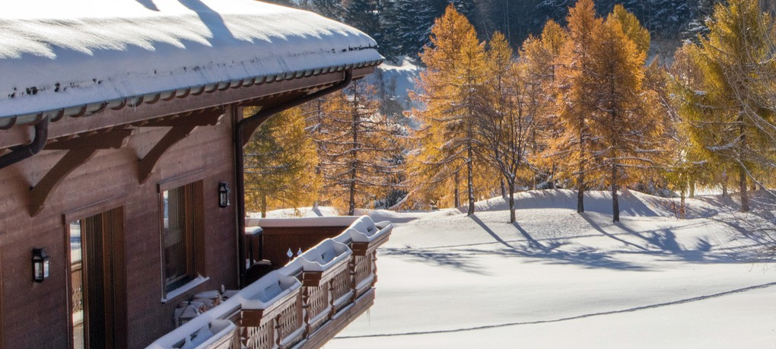
On multiple occasions, Guarda Golf Hotel & Residences has been awarded the 'Prix Bienvenue' by Switzerland Tourism as one of the most warm and welcoming luxury hotels throughout Switzerland. It is also consistently ranked as a top choice among guests on TripAdvisor and booking.com.

Romaine Travelletti
NORTH Communication romaine@north-communication.ch 079 580 73 36

