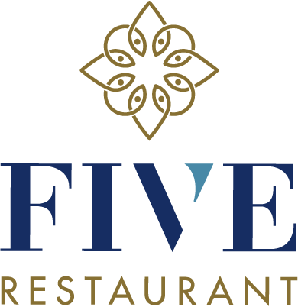
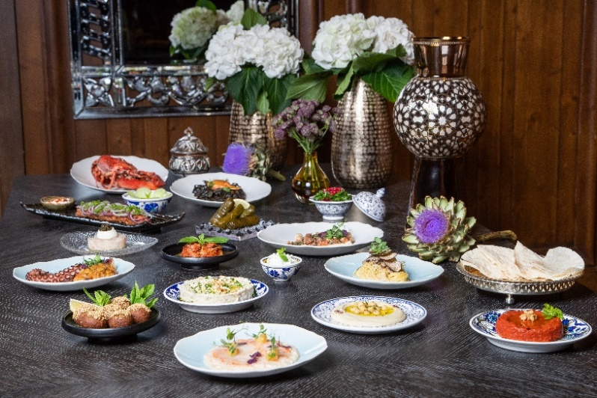
MEDIA RELEASE

Introducing a culinary concept which embraces the spirit of sharing, Guarda Golf Hotel & Residences prepares to launch a new restaurant inspired by Levantine and Italian cuisines
Crans-Montana, Switzerland, September 2020 – From this coming winter, Guarda Golf Hotel & Residences will entice her guests with a new culinary concept. The simply named Restaurant FIVE, will be inspired by five essential foundations: a generous welcome, convivial sharing, a respect of nature’s produce as well as the culinary heritage of the cuisines of the Levant and southern Italy.
A variety of Aegean and Levantine mezze, served in the fitting spirit of sharing, will begin the mouth-watering experience. These will be followed by Mediterranean-style grilled dishes, fresh pasta and risotti, before concluding with exquisite sweet creations. According to their own wish, guests will be able to enjoy their meal in either the main restaurant, on the terrace, in the lounge or in the bar. The latter area, also brand new, will complete the culinary proposition of Guarda Golf Hotel & Residences.
Executive Chef, Félicien Christe, has headed up the hotel’s kitchen brigade for many years already. For this project, in order to guarantee the authenticity of the Levantine fare and the Italian dishes, he will ally with several specialty chefs. Head Pastry Chef, Irina Kupenska, will continue to surprise us with her delicious sweet delights. For the occasion, Simon Schenk, General Manager of the establishment from 2014 to 2018, will return to Guarda Golf Hotel & Residences this winter, with the objective of supporting the owner, Mrs Nati Felli, and her team in the launch of Restaurant FIVE as well as with the management of the hotel in general.
“With the arrival of Restaurant FIVE, we aim to offer both our hotel guests and the residents of Crans-Montana and surrounding areas a cosmopolitan space that meets and satisfies the expectations of a modern and international clientele. In this sense, we continue with our aspiration to complement the culinary choices already available in Crans-Montana with this fresh and innovative addition. This is a philosophy that has guided us ever since the success of our Japanese restaurant which we introduced in 2016. We see it as our professional duty to continue to act as leaders within the sphere of luxury hospitality in the Valais and in Switzerland.” affirms Mrs Nati Felli, owner and founder of Guarda Golf Hotel & Residences.
Restaurant FIVE of Guarda Golf Hotel & Residences replaces the Japanese restaurant, MiZUKi by Kakinuma, which operated for four years in collaboration with the Kakinuma family, who are henceforth concentrating on new projects in Geneva.

About Guarda Golf Hôtel & Residences
Guarda Golf Hotel & Residences in Crans-Montana was founded by owners Nati and Giancarlo Felli and opened its doors in 2009. Since the opening, the hotel has been part of a select circle of the finest luxury hotels in Switzerland, as a member of Swiss Deluxe Hotels as well as of The Leading Hotels of the World. Perfectly located adjacent to the Jack Nicklaus golf course of Golf Club Crans-sur-Sierre in the centre of Crans-Montana, the hotel offers spectacular panoramic views over the Swiss Alps. Individual, personalized guest service is of the highest order, a philosophy that is put into practise daily in this establishment which consists of 23 rooms and suites, 7 Suite Apartments, 18 private residences, a restaurant with a large terrace, a lounge-bar, cigar lounge, billiard room, library and several private dining rooms. The hotel pays hommage to the legendary actor Sir Roger Moore, loyal friend to the hotel, with the 15-seat Sir Roger Moore Private Cinema. The Guarda Golf Spa features an indoor pool, jacuzzi, sauna, steam room, gym and private rooms for beauty treatments and massages with the international cosmetic brands of Biologique Recherche and KOS Paris. Finally, two conference rooms, equipped with state-of-the-art technology have a capacity of up to 120 persons.
In 2013 and again in 2018, Guarda Golf Hotel & Residences received the Prix Bienvenue Award by the Swiss Tourism Board for being named among the top three most friendly and welcoming luxury hotels in Switzerland. It is also consistently listed as one of the most appreciated luxury properties by travellers on TripAdvisor and booking.com.

Nicky Hawkins
Marketing & Public Relations
pr@guardagolf.com
+41 (0)27 486 2000

