PRESS RELEASE

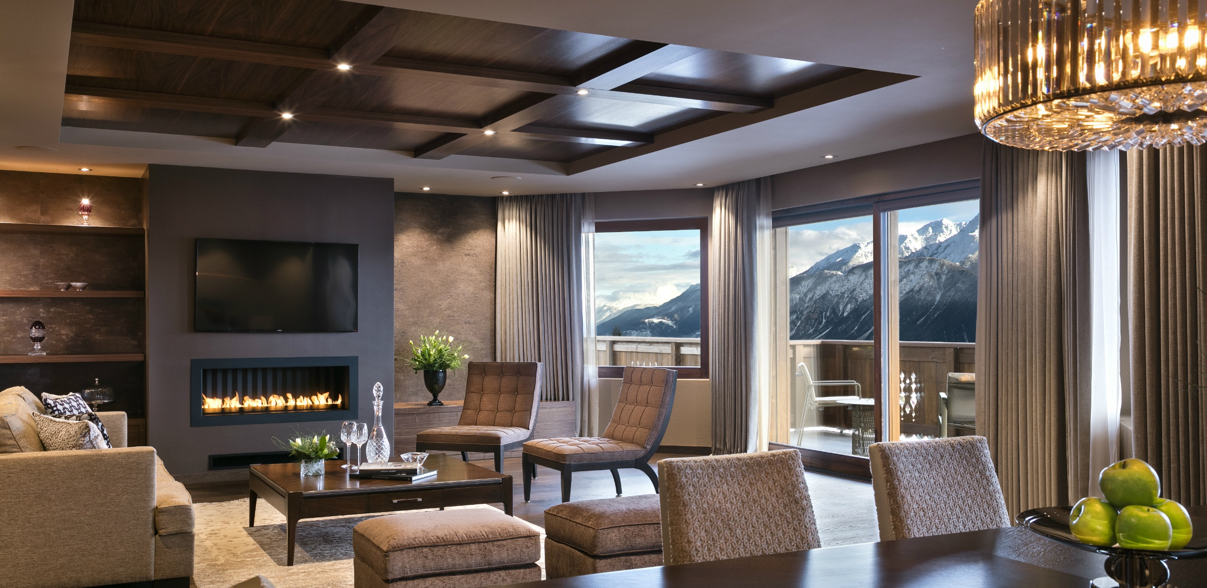

7 luxury suite apartments extend the hotel’s existing offer to a clientele that seeks the finest luxury, combining generous spaces and autonomy.

Crans-Montana, January 2018 – Guarda Golf Hotel & Residences reveals a whole new offer, culminating within the exclusive sphere of ultimate luxury. A new building, adjoining the original hotel offers 7 luxury suite apartments of 225m² each, fitted according to the standards required by the highest levels of excellence. The 6 floors also comprise a private cinema, billiard room, cigar lounge, library, private dining room and a games room for children.
Double the size, retaining intimacy, warmth and personalised service
Although the hotel has now doubled in size, the owner of the establishment, Mrs Nati Felli considers it to be of vital importance and her first priority to conserve the warm, personalised touch traditionally experienced by the hotel’s numerous loyal guests. Among them was Sir Roger Moore, friend to the hotel since its opening. Today, the hotel pays tribute to the legendary actor naming their 15-seat cinema, the “Sir Roger Moore Private Cinema”.
Ever since the opening of the hotel in 2009, Mrs Felli envisaged its expansion as part of a second phase. Now completed, the hotel’s capacity is raised to 23 bedrooms and junior suites within the main building and 7 suite apartments of 225m², each comprised of 3 bedrooms with en-suite bathrooms, 1 living room with fireplace, 1 kitchen and 1 large balcony with views over the golf course and the Alps. The absolute tranquillity that reigns, the spaciousness of the rooms and the autonomy made possible by the fully equipped kitchen all contribute to the enchanting experience. Guests may book a private floor with two adjoining suite apartments.

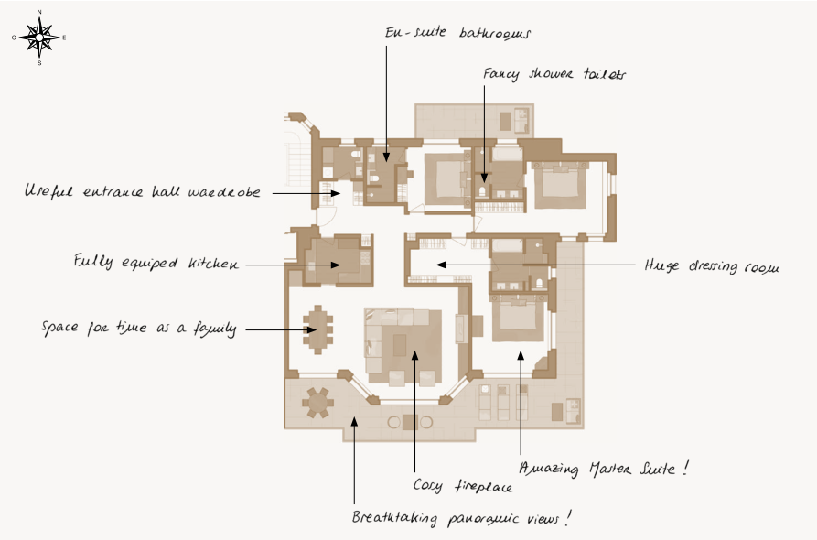

A unique high altitude offer
The complex as a whole represents a unique proposition among the luxury accommodation of Crans-Montana and reinforces the position of Guarda Golf Hotel & Residences as an undisputed leader of high-end hospitality in Switzerland.
The resort of Crans-Montana is reputed for its quality of life, clean air and advantageous climate, with over 300 days of sunshine per year. The area is outstanding for both families and sport lovers, with its world-famous golf club, magnificent ski slopes and the beauty of the surrounding nature.
Located only two hours from Geneva and three from Zürich and Milan, the resort is easily accessible, within the heart of the Swiss Alps.
For further information on Guarda Golf Hotel & Residences and its new extension, please visit www.guardagolf.com, or call +41 (0)27 486 2000.

About Guarda Golf Hotel & Residences
Guarda Golf Hotel & Residences in Crans-Montana was founded by owners Nati and Giancarlo Felli and opened its doors in 2009. Since the opening, the hotel has been part of a select circle of the finest luxury hotels in Switzerland, as a member of Swiss Deluxe Hotels as well as of The Leading Hotels of the World. Perfectly located adjacent to the Jack Nicklaus golf course and in the centre of Crans-Montana, the hotel offers spectacular panoramic views over the Swiss Alps. Individual, personalized guest service is of the highest order, a philosophy that is put into practise daily in this establishment, currently consisting of 23 rooms and suites, 7 Suite Apartments, 18 private residences, a refined Japanese Restaurant ‘MiZUKI by Kakinuma’ and a Lounge Bar, Cigar Lounge, billiard room, library and several private dining rooms. The hotel pays homage to legendary actor Sir Roger Moore, loyal friend to the hotel, by naming the 15-seat cinema, the “Sir Roger Moore Private Cinema”. The Guarda Golf Spa features an indoor pool, jacuzzi, sauna, steam room, gym and private suites for beauty treatments and massages. The international brand ‘Biologique Recherche’ is the main product range here. Two conference rooms have a capacity of up to 120 persons and state-of-the-art technical equipment.
In 2013, Guarda Golf Hotel & Residences received the ‘Prix Bienvenue’ Award by the Swiss Tourism Board for being named among the top three most friendly and welcoming luxury hotels in Switzerland. It is also consistently listed as one of the most appreciated luxury properties by travellers on TripAdvisor and booking.com.

