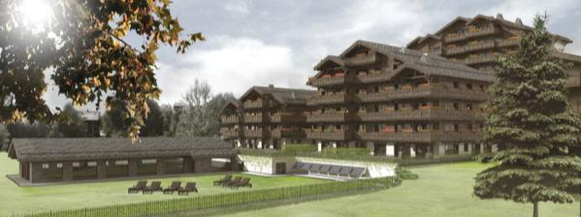

PRESS RELEASE

Guarda Golf Hotel & Residences
New property name in recognition of new developments

Crans-Montana, Switzerland, April 2015 – The Hotel Guarda Golf is changing its name to Guarda Golf Hotel & Residences in recognition of the serviced luxury apartments located within the perimeter of the hotel building, as well as those included in a significant extension project that is already well underway.
The hotel & residences extension includes three new buildings, two of which are due to be completed in the last quarter of 2015 and will be comprised of 13 privately owned, serviced luxury apartments with leisure and wellness facilities for the residents. These facilities will include a swimming pool, sauna, hammam and fitness room, as well as a private garden area. These new apartments are some of the most exclusive properties currently on sale in the Swiss Alps and most have already been sold.
The third building, due for completion in 2016, will be an impressive extension to the hotel, composed of 7 three-bedroomed Executive Suites; a tasteful addition that will nearly double the footprint of the existing building. Each Executive Suite will have a floor space of around 250m² and will feature three bedrooms with a separate living area and terrace, with south-facing views over the golf course and the Alps opposite. Each can be joined with another on the same floor, ideal for families and large delegations.
Further new additions to the hotel facilities will include a Private Dining room, a Home Cinema, new in-house boutiques and other features. The whole complex will be a unique addition to luxury accommodation available within the resort of Crans-Montana and reinforce the positioning of Guarda Golf Hotel & Residences as one of the undisputed leaders in luxury in Switzerland.
Crans-Montana is well renowned as an ideal place to live or to holiday, with pure air, over 300 days of sunshine a year, a safe environment and world-famous skiing and golfing facilities. Located just two hours from Geneva and three hours from Zürich and Milan, the resort is in the heart one of the most stunning Alpine settings of the region.

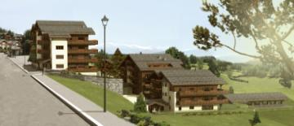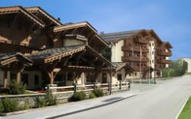
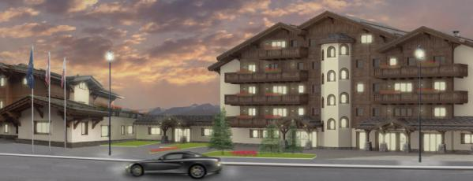

For more information about the Guarda Golf Hotel & Residences, the change of appellation or the extension, please visit www.guardagolf.com, or call +41 (0)27 486 2000.

About the Guarda Golf Hotel & Residences
The Guarda Golf Hotel & Residences in Crans-Montana was built by owners Nati and Giancarlo Felli and opened its doors in 2009. Since the opening, it has been part of a select circle of the finest luxury hotels in Switzerland and member of Swiss Deluxe Hotels as well as of The Leading Hotels of the World. Perfectly located adjacent to the Jack Nicklaus golf course and in the centre of Crans-Montana, the hotel offers spectacular panoramic views over the Swiss Alps to the South. Individual and personalized guest service is of the highest priority and is put into practise daily in this hotel, currently consisting of 25 rooms and suites, 8 private residences, the Giardino Restaurant, the Les Alpes Restaurant and a Lounge Bar. The Guarda Golf Spa offers an indoor pool, Jacuzzi, sauna, steam bath, gym and private suites for beauty treatments and massages. The exclusive and legendary Brazilian beauty products ‘Beauty by Clinica Ivo Pitanguy’ are available, as well as the Swiss natural cosmetic treatments by Eva.J. Two conference and meeting rooms, with state-of-the-art technical equipment have a capacity of up to 120 persons.
In 2013 the Hotel Guarda Golf received the ‘Prix Bienvenue’ Award by the Swiss Tourism Board and was selected as one of the top three most friendly and welcoming luxury hotels in Switzerland. It is also consistently listed as one of the most appreciated luxury properties by travellers on TripAdvisor and booking.com.

Media Contact
Nicky Hawkins
Sales, Marketing & Public Relations
pr@guardagolf.com
+41 27 486 2000

