PRESS RELEASE
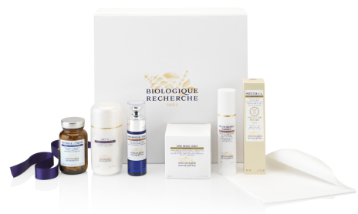
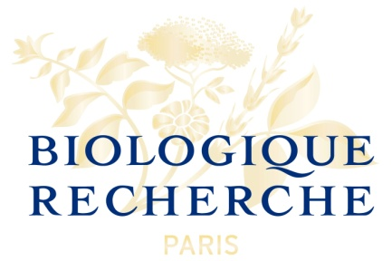

Guarda Golf Hotel & Residences introduces Parisian brand "Biologique Recherche" to products at award-winning spa

Crans-Montana, Switzerland, February 2017 - This winter, Guarda Golf Hotel & Residences added a new range of products by Biologique Recherche, complementing their existing product ranges and treatments. Highly popular with visitors to the Guarda Golf Spa, it is fast becoming a favourite among many of the regulars.

Biologique Recherche is a Parisian-based company, created by Yvan and Josette Allouche, a biologist and a physiotherapist respectively. The result of the partnership is a unique and highly effective combination of specific physiological treatment methods and pure, concentrated, almost raw products in a clinical approach to beauty treatments.

The therapists at the Guarda Golf Spa have received in-depth training at the hands of one of the company's experts and introduced a selection of three innovative facial treatments to their spa menu, the VIP Oxygen Treatment, a Restructuring & Smoothing Treatment and a Regenerating Vernix Facial, inspired by the mantel that covers a newborn infant's skin.

The Biologique Recherche brand is an outstanding addition to the Guarda Golf Spa's longstanding products, Beauty by Clinica by Ivo Pitanguy, by the late, world-renowned Brazilian plastic surgeon, Ivo Pitanguy, and Eva. J, a Swiss brand by Eva Johnston. Other signature treatments at the spa include a 4-day Sleep Therapy and Anti-Aging Oxygen Treatments with Le Cube O²+, a new technology that injects pure oxygen directly into the skin.

The Guarda Golf Spa extends over 600 square meters and features a heated indoor pool, whirlpool, sauna and steam room, as well as four treatment rooms and outdoor loungers in the summer. The Spa Suite is a private treatment room for two, including a private whirlpool and steam room. The spa is one of the best-reviewed spas of Switzerland and was recently listed among the Top 10 Swiss Spas over 1000m in altitude by the Handelzeitung, the only Valaisan spa of the list.

About Guarda Golf Hotel & Residences
Guarda Golf Hotel & Residences in Crans-Montana was founded by owners Nati and Giancarlo Felli and opened its doors in 2009. Since the opening, it has been part of a select circle of the finest luxury hotels in Switzerland and member of Swiss Deluxe Hotels as well as of The Leading Hotels of the World. Perfectly located adjacent to the Jack Nicklaus golf course and in the centre of Crans-Montana, the hotel offers spectacular panoramic views over the Swiss Alps to the south. Individual and personalized guest service is of the highest priority and is put into practise daily in this hotel, currently consisting of 25 rooms and suites, 8 private residences, a refined Japanese Restaurant ‘MiZUKI by Kakinuma’ and a Lounge Bar. The Guarda Golf Spa features an indoor pool, Jacuzzi, sauna, steam bath, gym and private suites for beauty treatments and massages. Exclusive Brazilian beauty products ‘Beauty by Clinica Ivo Pitanguy’ are available, as well as Swiss natural cosmetic treatments by ‘Eva.J’ and beauty treatments with the international brand ‘Biologique Recherche’. Two conference and meeting rooms, with state-of-the-art technical equipment have a capacity of up to 120 persons.
In 2013 Guarda Golf Hotel & Residences received the ‘Prix Bienvenue’ Award by the Swiss Tourism Board and was selected as one of the top three most friendly and welcoming luxury hotels in Switzerland. It is also consistently listed as one of the most appreciated luxury properties by travellers on TripAdvisor and booking.com.

About Biologique Recherche
For over 40 years Biologique Recherche’s unique methodology has built a strong reputation for astounding effectiveness based on a clinical approach to skincare, delivering immediate and long lasting results.
Combined with highly customized protocols and meticulous procedures which recondition the epidermis, Biologique Recherche’s extensive range of skincare products are highly concentrated in botanical, marine and biological active ingredients that are cold formulated in its own laboratory in France.
Biologique Recherche is the partner of choice in over 70 countries for exclusive medical spas and day spas in addition to the world’s premiere luxury hotel spas.

Media Contact
Nicky Hawkins
Sales, Marketing & Public Relations
pr@guardagolf.com
+41 27 486 2000

