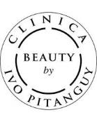
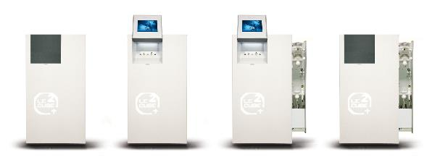
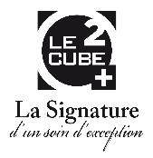

PRESS RELEASE

LE CUBE O² – New to the Guarda Golf Spa and Crans-Montana

Crans-Montana, Switzerland, June 2015 – This summer, the Guarda Golf Hotel & Residences is introducing a new and innovative form of treatment, harnessing the power and finesse of oxygen with the latest oxygen machine from LECUBE O², exclusively in Crans-Montana
In fact, medical research noticed the remarkable effects of pure oxygen when applied to the skin some time ago. Now a wide range of facial, scalp and body treatments have been designed to encourage cellular and dermal regeneration. With the LECUBE O², the Guarda Golf Spa is now offering the following range of treatments:
- O² Intense Treatment
- O² Radiance Treatment
- O² Eye Control Treatment
- O² Needling Rejuvenate Treatment
- O² Anti Cellulite and Toning Treatment
The spa team at the Guarda Golf Spa have followed intensive training in the use of this technology, which includes an endodermic vacuum, oxygen propulsion, O2 needling, an oxygen nebuliser and oxygen-based aromatherapy for a complete range of treatments.
The Guarda Golf Spa will be pairing these treatments with the Beauty by Clinica Ivo Pitanguy skincare products - created by world-renowned, Brazilian expert cosmetic surgeon, Professor Ivo Pitanguy – for the ultimate skin renewing treatments.
Treatments are available to hotel guests and external guests alike. The Eye contour treatment is priced at CHF 140.- and facial treatments start at CHF 480.-. Bookings are available from 19th June.
For more information about the Guarda Golf Spa and the LECUBE O² oxygen treatments, or to make your reservation, please visit www.guardagolf.com, or call +41 (0)27 486 2000.

About the Guarda Golf Hotel & Residences
The Guarda Golf Hotel & Residences in Crans-Montana was built by owners Nati and Giancarlo Felli and opened its doors in 2009. Since the opening, it has been part of a select circle of the finest luxury hotels in Switzerland and member of Swiss Deluxe Hotels as well as of The Leading Hotels of the World. Perfectly located adjacent to the Jack Nicklaus golf course and in the centre of Crans-Montana, the hotel offers spectacular panoramic views over the Swiss Alps to the South. Individual and personalized guest service is of the highest priority and is put into practise daily in this hotel, currently consisting of 25 rooms and suites, 8 private residences, the Giardino Restaurant, the Les Alpes Restaurant and a Lounge Bar. The Guarda Golf Spa offers an indoor pool, Jacuzzi, sauna, steam bath, gym and private suites for beauty treatments and massages. The exclusive and legendary Brazilian beauty products ‘Beauty by Clinica Ivo Pitanguy’ are available, as well as the Swiss natural cosmetic treatments by Eva.J. Two conference and meeting rooms, with state-of-the-art technical equipment have a capacity of up to 120 persons.
In 2013 the Hotel Guarda Golf received the ‘Prix Bienvenue’ Award by the Swiss Tourism Board and was selected as one of the top three most friendly and welcoming luxury hotels in Switzerland. It is also consistently listed as one of the most appreciated luxury properties by travellers on TripAdvisor and booking.com.

Media Contact
Nicky Hawkins
Sales, Marketing & Public Relations
pr@guardagolf.com
+41 27 486 2000

