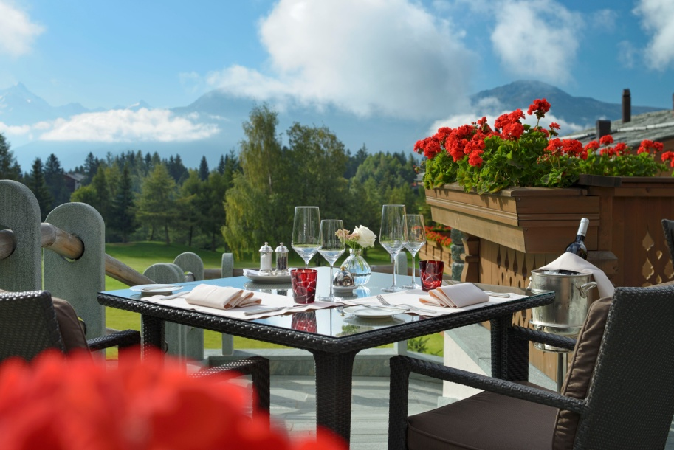
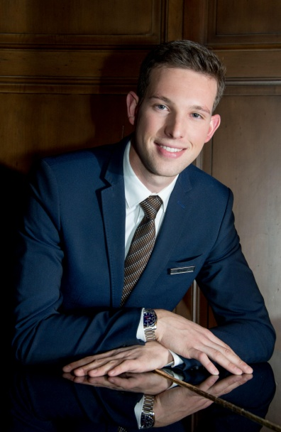

PRESS RELEASE

Kevin Baruselli Restaurant Manager of the Year 2016

Crans-Montana, Switzerland, 29th July 2016 – Kevin Baruselli, 28, Restaurant Manager for Guarda Golf Hotel & Residences, has been named Restaurant Manager of the Year 2016 by Bilanz Magazine, in recognition of his impeccable service standards. Bilanz Magazine’s yearly hotel rating is the most respected in Switzerland.
Kevin is one of the youngest ever winners of this award and has received so many congratulations since its announcement that he says that he feels like he has won an Oscar. "I was so surprised when I was told the news. I am incredibly proud, especially as I am so young and feel like I still have so much to learn."
He first trained in a Michelin-starred restaurant in his Swiss home town of Neuchâtel, his career since then taking him around the world, always in some of the best restaurants and most luxurious hotels. Despite this illustrious background, he does not like the stiff style of service that is so often associated with fine dining, preferring to connect with his guests in a more open and personal manner. Throughout his day, he remains aware that people visit the restaurant not just to have a meal, but to enjoy a memorable time with friends and family. When they leave the restaurant saying "See you again soon", then he knows that he has succeeded.
When asked why he thinks that he was singled out for this award, his response is simple: "A good hotelier and restaurateur prepares for his shift as if he is going on stage. I love the theatre of service and think that this is what tipped the balance in my favour".
Kevin is not the first person at the Guarda Golf Hotel & Residences to be recognised by Bilanz Magazine. The owners of the hotel, Giancarlo and Nati Felli, were named Entrepreneurs of the Year in 2013 for their passion in creating a hotel that is listed among the best in the world. The same passion that drives Kevin to keep perfecting his art.
Guarda Golf Hotel & Residences has also been impressively distinguished in this year's Bilanz Hotel Rating, climbing three places to become the 22nd Luxury Hotel in Switzerland and becoming the top leisure hotel in French-speaking Switzerland.
For more information about Kevin Baruselli and Guarda Golf Hotel & Residences, please call +41 (0)27 486 2000.

About Guarda Golf Hotel & Residences
Guarda Golf Hotel & Residences in Crans-Montana was built by owners Nati and Giancarlo Felli and opened its doors in 2009. Since the opening, it has been part of a select circle of the finest luxury hotels in Switzerland and member of Swiss Deluxe Hotels as well as of The Leading Hotels of the World. Perfectly located adjacent to the Jack Nicklaus golf course and in the centre of Crans-Montana, the hotel offers spectacular panoramic views over the Swiss Alps to the south. Individual and personalized guest service is of the highest priority and is put into practise daily in this hotel, currently consisting of 25 rooms and suites, 8 private residences, a fine-diningrestaurantand a Lounge Bar. The Guarda Golf Spa offers an indoor pool, Jacuzzi, sauna, steam bath, gym and private suites for beauty treatments and massages. The exclusive and legendary Brazilian beauty products ‘Beauty by Clinica Ivo Pitanguy’ are available, as well as the Swiss natural cosmetic treatments by Eva.J. Two conference and meeting rooms, with state-of-the-art technical equipment have a capacity of up to 120 persons.
In 2013 Guarda Golf Hotel & Residences received the ‘Prix Bienvenue’ Award by the Swiss Tourism Board and was selected as one of the top three most friendly and welcoming luxury hotels in Switzerland. It is also consistently listed as one of the most appreciated luxury properties by travellers on TripAdvisor and booking.com.

Media Contact
Nicky Hawkins
Sales, Marketing & Public Relations
pr@guardagolf.com
+41 27 486 2000

